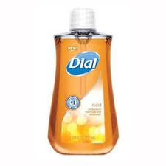
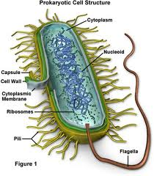
List the 2 new characteristics learned about prokaryotic cells
( bacteria) today?

Homework
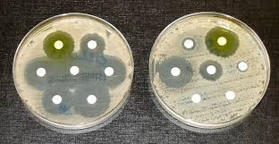
Name________________
Date_________________
Write an ECR on bacteria and antibacterial resistance.
- What is a modern day characteristic that has evolved in bacteria? (2pt)
- How has this characteristic evolved?(2pts)
- What threat does this characteristic pose to humans and livestock?(4pts)
- What can we do to possibly eradicate this threat to humans? (4pts)
____________________________________________________________________________________________________________________________________________________________________________________________________________________________________________________________________________________________________________________________________________________________________________________________________________________________________________________________________________________________________________________________________________________________________________________________________________________________________________________________________________________________________________________________________________________________________________________________________________________________________________________________________________________________________________________________________________________________________________________________________________________________________________________________
______________________________________________________________________________________________________________________________________________________________________________________________________________________________________________________________________________________________________________________________________________________________________________________________________________________________________________________________________________________________________________________________
______________________________________________________________________________________________________________________________________________________________________________________________________________________________________________________________________________________________________________________________________________________________________________________________________________________________________________________________________________________________________________________________

