Conservation, Career, and Art Workshop at Cornell University Ornithology Lab
by: Nanyamka Anderson, 11th grade student at Augusta Fells

A group of students from Augusta Fells Savage Institute of Visual Arts and two more schools in Baltimore City traveled to Cornell University Ornithology Laboratory at Ithaca, N.Y. on October 24th-25th, 2013 to participate in the two-day conservation, career, and art workshop. Augusta Fells Savage’s “Green Club” members Nanyamka Anderson, Felicia Woolridge, Michelle Turner, Ni’Imah Bean, Andrea Cottman, Rodwick Holley and Devontay Carter were the seven out of 24 student participants from the Northeast. The students were nominated and accepted in a full scholarship grant for the two-day all expense paid trip to Cornell University. The scholarship covered travel, accommodations, food, and other workshop expenses. In the duration of the trip, the students were housed in a hotel and attended the workshop at Ornithology Lab. The entire workshop was filled with new knowledge about the study of birds, conservation efforts, different career opportunities and career pathways, exploration and personal experiences with nature, national and global-based research presentations from the scientists, university tour, and art lessons presented by highly respected science staff, artists and researchers. In the two-day stay at Ornithology Lab, the students enjoyed cutting-edge conservation science and were inspired to be engaged in community-based stewardship projects.

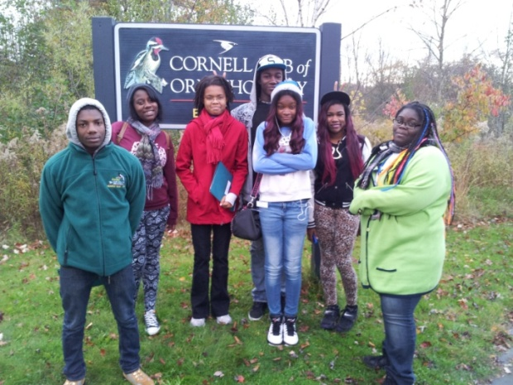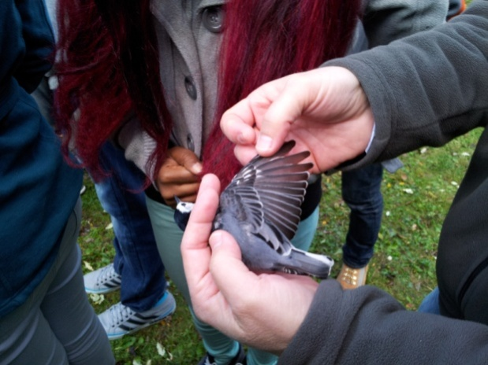

Day 1
The first day started and filled with lectures and cool activities, though they were all amazing some stood out more than others, below are the four activities that I think impacted us the most:
- Bird Banding: This consisted of all the students from Baltimore city schools as well as other schools from the Northeast. Students, parents, and teachers were lead by Cornell University’s students outside for a bird banding activity. It was so cold but somehow they got birds inside the brown paper bag and many wondered how they did it. They carefully took the birds out of the bag so they could place tiny bands around their tiny bird feet. In this activity we have learned cool things. We learned that bird banding was done for research and learning purposes. They taught us the proper way to hold a bird; holding between your index finger and your middle finger carefully but firm. They assessed the bird’s condition by checking their fat reserves and they did it by blowing air on the bird’s belly area to see how much fat was accumulated. They weighed them, put the tag, and then we set them free.
The second half of bird banding consisted of us looking at two more different kinds of birds and we all soon figured out that they caught the birds in nets. This process is very similar to how fish nets work the only difference is that this net is suspended in the air to catch birds. By doing this they could easily catch birds and transfer these tiny creatures in the bag to quickly make their assessments, few of us were able to hold the birds and after banding we set them free.

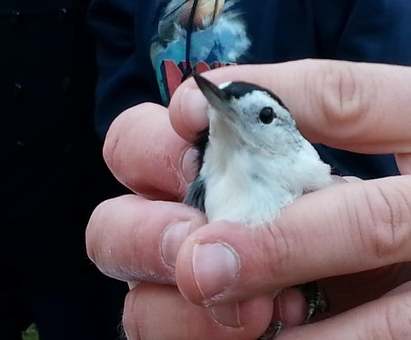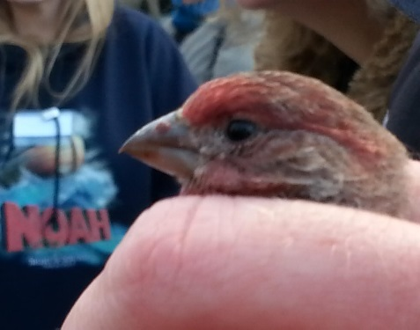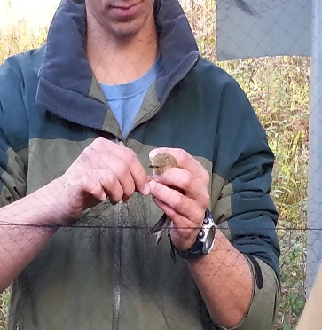
Caption: These are a few pictures of the process of bird-banding, the first two being the first half the last being the second half. These are all pictures taken on the Cornell Lab of Ornithology.

- Introduction to the Macaulay Library of Natural Sounds and Evolutionary Biology: We did this part of our trip later in the day after we introduced ourselves to one another and had discussions about bird conservation by two students from Cornell, a talk about dinosaurs and how they are relevant to birds and feathers, followed by a talk from a web-designer who worked for Cornell. Touring the Macaulay Library gave us an introduction to Cornell Lab of Ornithology library which was a record of bird sounds, some taped from decades ago all up to the present time. The library was extensive and there were three library staffs that showed us what they did and what their job at the Cornell’s Library for Birds is like. We were split up into three groups, the staff assigned to us took us to her work place and we listened to records of bird sounds and other animals from places she visited. She talked about how you come across things that you’re not even intending to record; sometimes you just record them by chance. She played an alligator sound which wasn’t even on purpose. She also played frog’s sound. It was amazing how sound was both a work of art a field of science. After our time was up, we moved to our next guide where he took us to his workplace which was a bit larger compared to the first room we visited. He was an archivist who was trained to catalog animal sounds. He let us listen to sounds from whales which were amazing and enchanting songs. We listened to some more animal sounds and he let us guess the animal that made the sound. We asked some questions about the sounds and he explained to us how they used certain equipment to record the sounds of animals in the wild, like trying to get sounds from an insect calling out to its mate. In doing this, you really need to focus on using the right technique and equipment to record the get the best sound quality. When were done with his presentation, we went to our last destination where the staff told us a little about him being in the military before he came to Cornell. He mentioned that sounds are always interesting to him. He showed us Cornell’s website and took us to a section that if you typed in a certain bird’s name it will bring to a collection of videos where you can actually play and listen to their calls. The collection is not only limited for birds but also for other animals like whales. He then typed in the names of Maryland birds more specifically those from Baltimore. We saw and listen to the calls of certain types birds like crows, orioles, seagulls, and osprey that lived in our home state. We could have typed in things forever but our time was up with him and he gave us much information and new knowledge that was not known to us prior to our visit.

- Trip to Cornell Campus: We went to Cornell’s main campus in the evening where two college students served as our guides in touring the campus. They started by giving us a quick overview of Cornell’s different colleges. We split into two groups; the group I was in was guided by this well-versed student who walks backwards as he shares everything he knows about the campus. He took us to the church on campus that have catholic mass routinely celebrated and to accommodate people of certain beliefs. He explained that in the early years, Cornell was not catered to any specific religion or denomination and they didn’t have anything like a church on campus. After our stop to the church, he took us to the dining hall for students where he explained that they offered meal plans for certain things. He also explained to us how they have certain events and festivities in the campus and that there are a lot of things to do and there are always something going on at Cornell. We continued to our tour and began to walk up this very steep hill on the campus. There were two sections he showed us when we got to the top of the hill; the first was the very old dorms. At the bottom of the hill were the male dorm and to get to class they had to walk up this hill. He also talked to us about having to take a physical education course as a requirement like swimming and other recreational sports, he also mentioned therapeutic classes are taken as a physical education credit for college students but it’s all up to the students to choose which one are interested to, he also mentioned that if you don’t want to get active at all you can just take a course about sitting down and writing about what you would do if you were actually active. It’s cool that our guide showed us the different cultures, academic requirements, the different colleges and buildings at Cornell University. After all of the countless things our tour guide showed and told us, the university tour was not yet over. Our workshop coordinator, Ms. Karen Purcell met us and guided us to the cafeteria for a dinner. I think it was a great experience to eat at the cafeteria and have that feeling of being a college student. We had a blast talking and eating some pretty good food, it’s a buffet style dinner where you can eat anything you want and they serve a wide variety of food that ranges from Asian, Vegan, and American foods. When we finished eating, we have to take the tray and the utensils to the dishwashers. I like that there was a very cool project going on in the cafeteria, that is when you’re done with your plates you bring your leftovers to these students who measure the amount of food you had leftover and your liquids were dumped to bucket to be measured. I could imagine how comprehensive the statistics they take in a day.

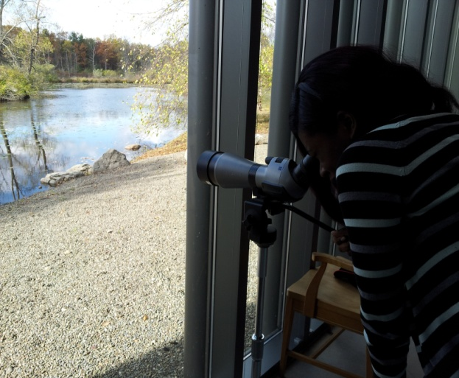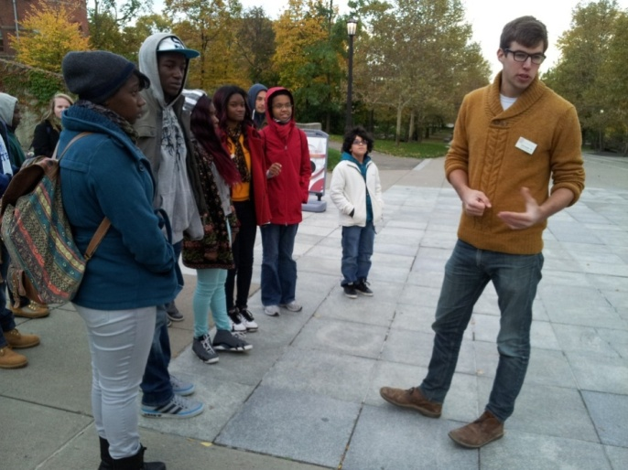

- Night Walk in Sapsucker Woods: After dinner, the last part of what we had to do for the day was to take a night time walk in the woods on a trail. We had to appreciate the silence of nature which I think we did for the most part very well. Everyone kept extremely quite respecting and preserving the quietness of the night and what was left of the wilderness. It was so dark that you would barely be able to see yourself or anyone else for that matter but at the same time it was so light because of the moon’s reflection. In this dark and quiet environment our senses (hearing and sight) were heightened and our body focused on the environment around us. Though many people were scared, there were also others who cherished the moment of silence listening to the sounds of the wild at night including the birds’ sound. We took short breaks looking out where the water started and remained silent with occasional talks from Ms. Purcell. When we came back to the lab, I believe everyone had a new found respect for nature and that we were a part of its beauty.

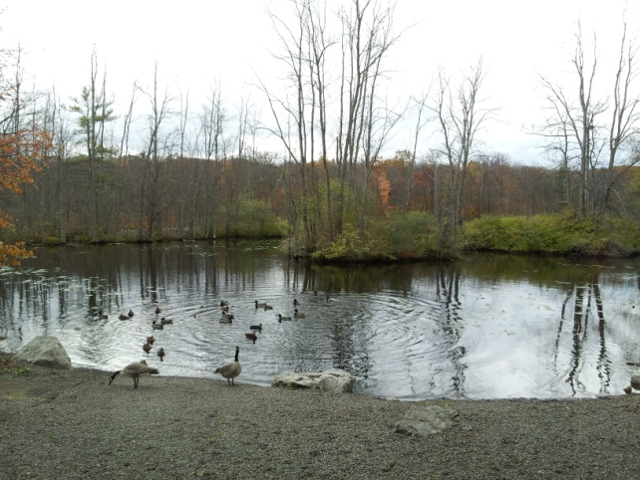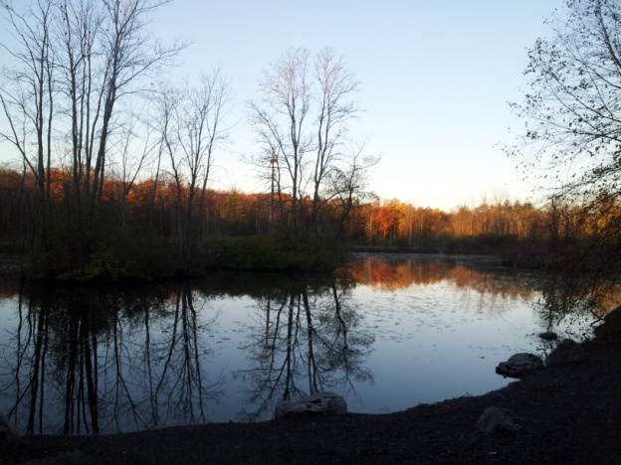
Day 2
- Bird Walk in Sapsucker Woods Sanctuary: In the daytime things look and feel differently. We went back to the same trail we walked on at night and found that it seemed to have a different face at day. It was fairly bright outside and helpful that we could see more clearly with our eyes. Before we embarked on the exploration, we had a guide he was a man with glasses who had been doing bird watching for years and he was going to lead us through in the bird watching activity. Each of us had binoculars while he had his own large stationary binoculars. We then went out and he taught to us how to use the binoculars and how to look for certain birds and we did this for about an hour. As moved on to the Sapsucker woods, our guide made some bird noises to trigger a response from birds (like woodpeckers) so we may be able to hear them and see the bird’s reaction. We had found about 4 different bird species at that time. I have learned from this activity that bird watching can easily become addicting for nature lovers like our guide. The walk eventually came to a close and we learned that certain predatory bird noises can either make a certain bird species flee or lash out at its predatory threat. We also learned what to look out for in identifying birds like bird call, colors, and behavior. Bird watching is hard for the first try and it takes practice, skills and knowledge to master.

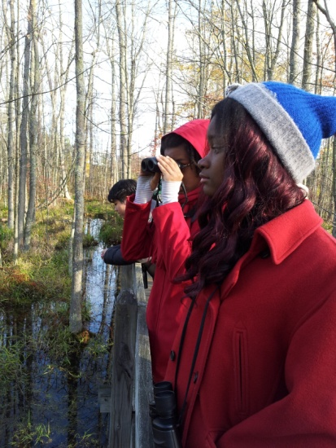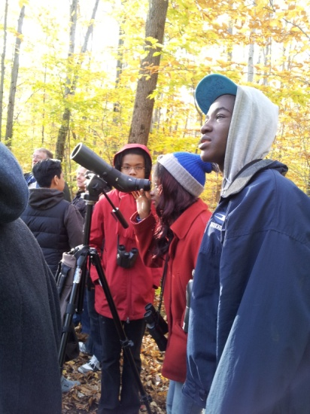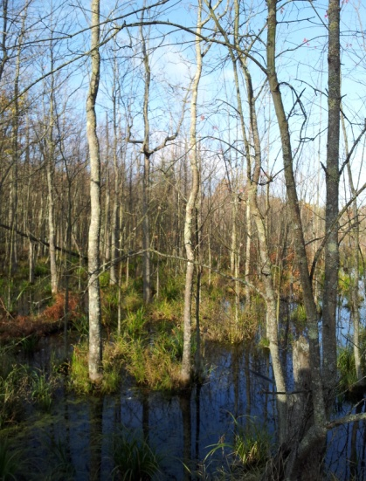

- Citizen Science (Connecting Communities to Sciences and Conservation): From this talk we learned more about how participation in citizen science is helpful when communicating scientific discoveries and findings to the community. Communicating and connecting discoveries with others makes more and more research easier, especially when everyone is pitching in with their observations. When everyone communicates we all learn something. And if you’re concerned about something, connect with others and communicate with them. Then work with them and do something about your findings. We learned more about conservation through communication with others and when you spread the message of conservation, more and more people will know where to start taking care of the planet and conserving its natural beauty.

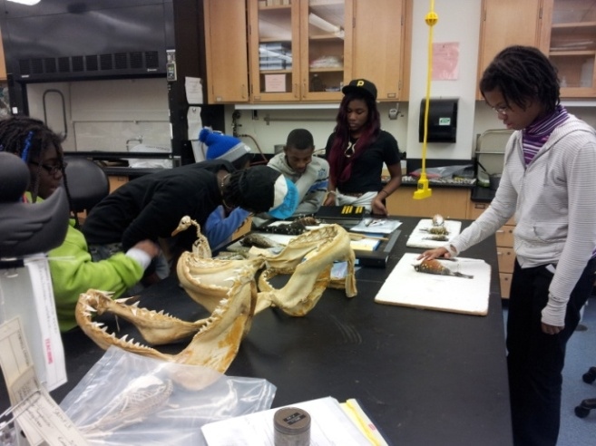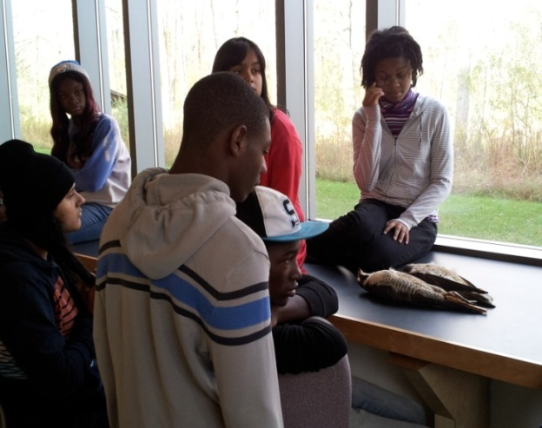

- Bioacoustics: This consisted of a speaker who first explained what bioacoustics is which the study is of sounds of animals like birds and whales. At first we had technical difficulties but they were fixed quickly. One exercise we did was when three volunteers were chosen and he basically told one of the two students to call out to the other one who were just listening while their eyes were close. The student only recognized the girl that he knew because he recognized her voice and the other girl who called turned out to be unrecognizable because he didn’t know her very well. The speaker explained that animals like whales communicate in a similar way; for example a mother whale calling out to her baby whale, the baby recognizes its mom’s voice and distinguishes her voice from other whales. He told us that whales have a very good sense of hearing and that they can communicate with each other miles and miles away. Then the speaker started to talk about how human activities impacted the type of communication these animals have. He explained to us how machines have mimicked this sonar that animals use to communicate. He showed us a few more videos about bioacoustics and we learned that bioacoustics is helpful to animal survival.

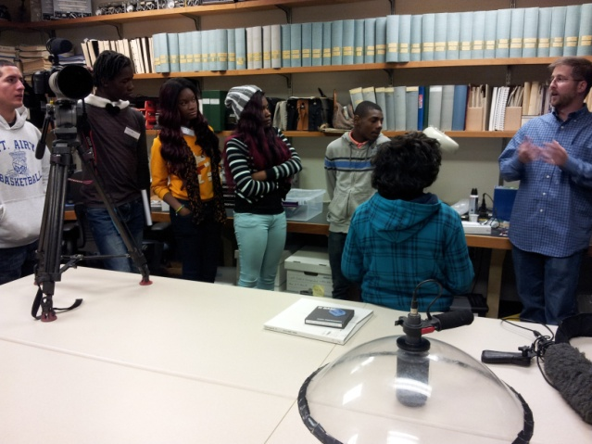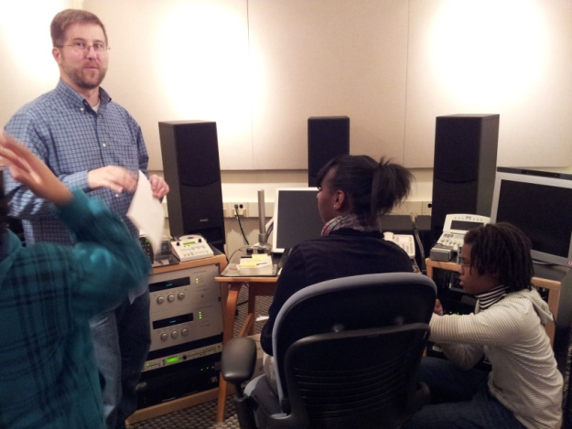

- Lesson on the Role of Art in Conservation: Later in the day we had a talk and a bit of free time. Before the talk has started we were given a set of art supplies that we used later in the day. The talk was given by this young man who worked for Cornell Ornithology lab, he used is artistic skills by making bird posters to send the message of conservation. I think that this young artist is very smart that he used his skills to call for conservation and so that people can start caring and understanding more about birds. His beautiful artwork includes the Black-capped Chickadee, Rufous Hummingbird, and Western Bluebird. After that he gave us a quick lesson on that includes basic art techniques. He started out with simple shapes to form the basics of the body of the subject, he then went to detail connecting certain shapes to one another and then it began to resemble more of a bird. He later switched his pencil from an HB which is like a number two pencil to a darker pencils ranging from 2B-4B pencil which is softer in texture and bolder. Every single technique he showed us was very helpful in developing our skills. After he showed us his skills and talent, he gave us time to practice drawing the nature we see outside the building. He also walked around checking on everybody and offered assistance on how to improve our drawings.

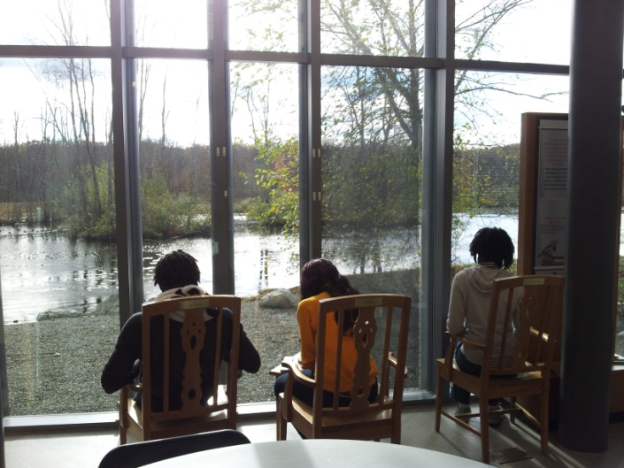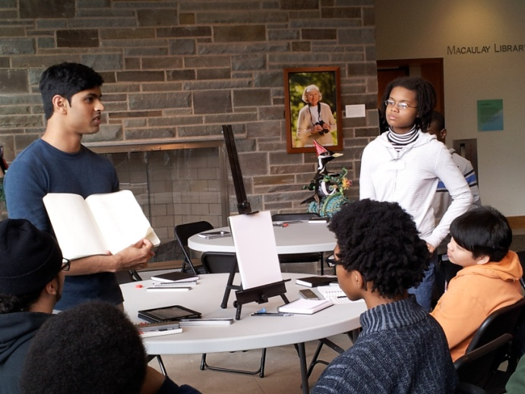

Cornell Lab of Ornithology Trip Conclusion: The trip was amazing and I wish I could remember every detail to share with my peers and classmates at Augusta Fells. One thing I can say about this wonderful opportunity is that it’s an eye-opener and amazingly widen up my horizon. It was what we got from this opportunity that let us get out of ourselves and we have learned so much from the hands-on activities, tours and lectures. We learned more about the importance of conservation and what we can do to help the planet; we learned the different careers and the many different ways to get there. Without this trip we would not probably have the knowledge and skills we have right now. This trip was very memorable and a trip like this helps students to learn more and be more engaged and motivated in preserving, protecting and cultivating the beauty and positive things our planet Earth have.
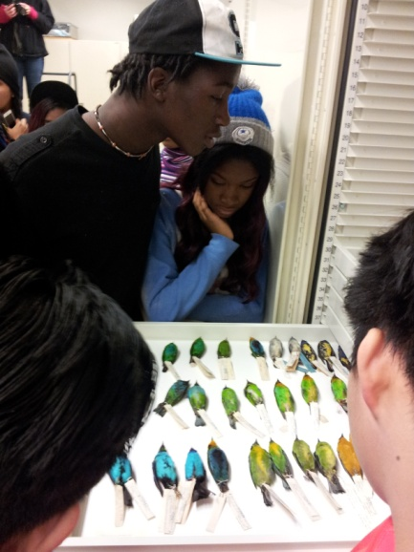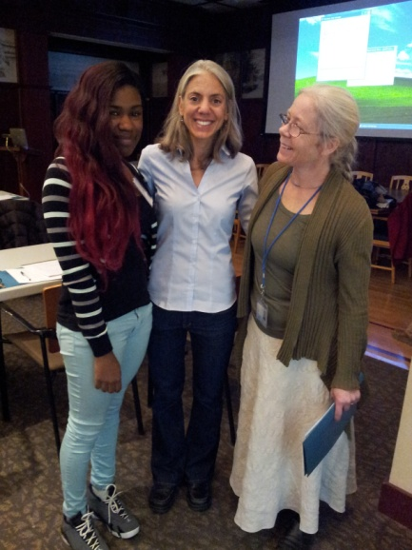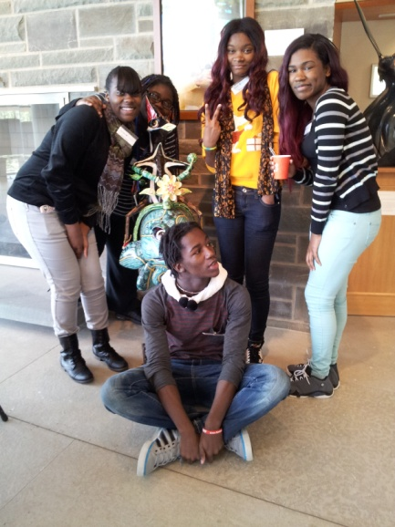

These are a few quotes from students who experienced this amazing field trip:

“Honestly I really enjoyed the trip. It opened my eyes up to different opportunities.”
- Rodwick Holley

“Walking through the woods in the dark was a real eye opener; the whole trip was amazing.”
– Andrea Cottman

“The night walk really had me think, I was thinking about how I could change my ways back home for the better. Because when you aren’t talking you have more time to think.”
-Felicia Woolridge

“I had a blast during the tour; I actually had a chance to visit lots of different buildings like the art department, the science department, the church at Cornell, etc.”
-Michelle Turner

“I like the night walk in the woods because it was so quiet and you can hear the bird’s activity.”
-Ni’Imah Bean

“I am so grateful that I was able to go on such a huge experience that opened my horizons and my peers’ horizons, and even though I’m a teen I can still positively impact the lives of animals, plants and the people who live on this earth, because it’s our job to take care of it.”
-Nanyamka Anderson

