**PROCEDURE for each Method**

**1. Evaporation with a solar still**

*Materials for each group:*

4 – large container

4 – small container

4 small stones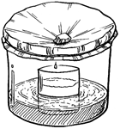

Plastic wrap

Conductivity meter

Scale

4 Teaspoons

Tape

Sharpie Marker

Part I

1. Use tape and Sharpie Marker to label each large container with your group name and substance (soil, oil, fertilizer, or salt).

2. Add 1 teaspoon of each of the appropriate mixture to each large container.

3. Record the mass on your ‘**Schoolyard Substances Lab Sheet.’**

4. Fill the large container to the 50 ml line and stir well.

5. Measure conductivity and record on the lab sheet.

6. Place a small container in the middle of each large container. ***Do not to contaminate the inside of the small container with any of the mixture.***

7. Cover the top of each large container with plastic wrap. Tape the ends of the plastic wrap to make sure it makes a tight seal. Air cannot be allowed to get in or out of your still.

8. Place a small stone on the plastic wrap just above the center of the small container.

9. Place your container near a sunny window or under a lamp.

Part II

1. Allow the bowl to sit until the bottom of the container is dry.

2. Carefully remove the plastic wrap and remove the small container from the large container.

3. Fill out the rest of your ‘**Schoolyard Substances Lab Sheet’** with final conductivity in the small container, the mass of the large container and its remaining contents, and your visual observations.

*Based on this experiment predict do substances in water evaporate with the water? Could polluted water make polluted rain?*

**2. Effect on a light beam**

*Materials for each group:*

Flashlight

4 – containers

Tape

Sharpie Marker

Teaspoon

1. Label each large container with your group name and substance (soil, oil, fertilizer, or salt).

2. Add appropriate substance and 200 mL of water to each container and mix well.

3. Shine a flashlight through each of the containers.

4. Record your observations in the ‘**Schoolyard Substances Lab Sheet.’**

*Which substances could affect the amount of light reaching aquatic plants?*

**3. Celery Stalk**

*Materials for each group:*

4 – labeled beakers with mixtures from light beam experiment

4 celery stalks with leaves

1. Add a celery stalk to each beaker from the light beam experiment and place the beakers in a sunny location.

2. Over the course of a week, record your observations in your ‘**Schoolyard Substances Lab Sheet.’**

*Which substances could affect plant life?*

**4. Soil column**

*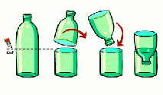Materials for each group:*

4 clear plastic water bottles

4 mesh screen squares (10 cm x 10 cm)

4 rubber bands

Scissors

4 – beakers from celery stalk experiment

Media (ex. sand, rocks, and/or soil)

Tape & Sharpie Marker

1. Label each bottle with your group name and substance (soil, oil, fertilizer, or salt).

2. Fasten the mesh screen tightly over the mouth of each bottle using a rubber band.

3. Carefully cut the bottle in half as shown in the diagram.

4. Turn the top half bottle upside down and place in the bottom half of the bottle as shown.

5. Fill the inverted bottle top half way with media. Now your soil columns are ready.

6. Remove celery stalks from beakers, stir each mixture, and slowly pour it into appropriately labeled soil column.

7. Allow all of the surface water to drain through the soil column into the groundwater reservoir represented by the bottom bottle half.

8. Measure the conductivity in the groundwater reservoir and record you observations.

*Which substances will travel with water into groundwater?*

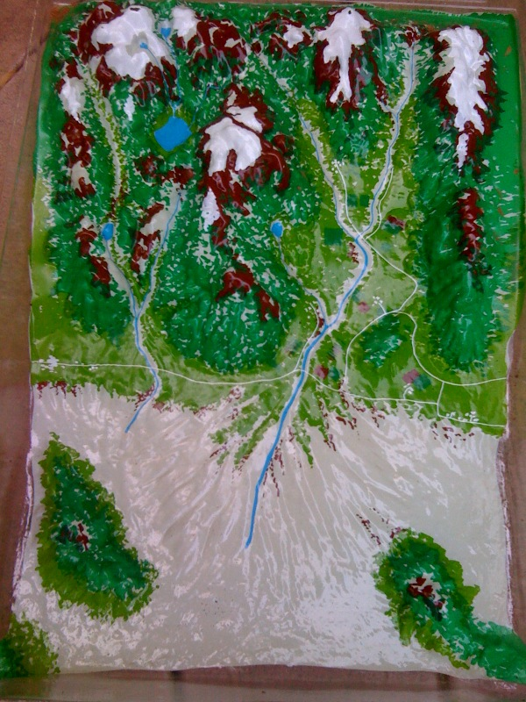**5. Surface Water Chute**

*Materials for each group:*

Watershed model

Tablespoon

4 - labeled buckets for waste disposal

Spray bottle with water

Watering can

You will test each substance one at a time (soil, oil, fertilizer, or salt).

1. Place a tablespoon of soil at the top of the paint tray.

2. Mist it with water using the spray bottle and record you observations in the ‘**Schoolyard Substances Lab Sheet.’**

**3.** Pour water from a watering can over your substance and record you observations in the lab sheet.

*Which substances will travel with surface flow? Does the velocity of the water matter?*